MCB201
KingdomProtista containstheprotists,oralltheorganismsthatdonotfitintotheotherkingdomsoflife.Protistscanbeheterotrophicorautotrophic,mobileorimmobile,single-celledormulti-celled,solooramemberofacolony.Theyarecategorizedintothreemaincategoriesbasedonhowtheyobtainnutrients
Allkingdomsoflivingorganismscanbebroadlycategorizedaseither eukaryotes or prokaryotes.Eukaryotesdifferfromprokaryotesbecauseofthepresenceof membrane-boundcellularorganelles,suchasanucleus,chloroplast,andmitochondria.
Whileallprokaryotesaresingle-celled,eukaryotesincludebothsingle-celledorganismsaswellasmulticellularorganisms.Underthesixkingdommodelofclassification,prokaryoticorganismsoccupytwokingdoms(Eubacteria,andAchaebacteria),whiletherearefourkingdomsofeukaryoticorganisms(Protista,Plantae,Animalia,andFungi).
MembersoftheKingdomProtistaareeukaryotesanddisplayadiverserangeofcharacteristicsthatvarygreatlybetweenspecies.Forexample,protistscanvarygreatlyintermsofsize.Marinepicoplanktonarethesmallestknownprotistswithanaveragediameterofonly1micrometer,whileoneofthelargerknownprotistsarethemulticellulargiant kelp

Microorganismsareofgreatsignificancetofoodsforthefollowingreasons:(1) microorganismscancausespoilageoffoods,(2)microorganismsareusedtomanufactureawidevarietyoffoodproducts,and(3)microbialdiseasescanbetransmittedbyfoods
Foodspoilage
HowsmarttagscanindicatefoodspoilageLearnaboutscientificresearchintosmarttags,smallgel-liketagsonfoodpackagingthatchangecolourtoindicatespoilageoccurringinsidethecontainers.
Foodscanbeconsideredasamediumformicrobial growth
MAJORNUTRIENTSFOUNDINFOOD:PROTEINS,CARBOHYDRATES,ANDFATS.
Protein-containingfoods,particularlymeats,areputrefiedbyorganisms(e.g., Proteus, Pseudomonas,and Clostridium bacteria)thatbreakdownthelong peptide chainsofproteinsintoaminoacidsandfoul-smelling compoundsamines₂S).
Carbohydrates(sugars and starches in vinegar), alcoholsyeasts.
Fat-containingfoodssuchasdairyproductsarespoiledbymicrobesthatbreakdownlipidsinto fattyacids and glycerolbacteria, yeastmold
Improperly cannedBacillus and Clostridium areofparticularsignificanceinthecanningindustrybecauseofthehighlevelofresistancethattheirsporespossess.Oneexampleofmicrobialspoilageofcannedfoodsis“sulfidespoilage”causedby C.nigrificans,inwhichcontentsareblackenedandhavetheodourofrotteneggs.Anotherexampleiscalled“flatsour,”inwhichthespoiledproducthasanabnormalodour,acloudyappearance,andasourtasteowingtoitsloweredpH.Putrefactioncausedby C.sporogenes maycauseacanto swell

Foodpreservation
Allmethodsof foodpreservation arebasedupononeormoreofthefollowingprinciples:(1)preventionofcontaminationandremovalofmicroorganisms,(2)inhibitionofmicrobialgrowthand metabolismradiation.

Foodproducts frommicroorganisms
Importantfooditemsproducedinwholeorinpartbythebiochemicalactivitiesofmicroorganismsincludepickles,sauerkraut,olives, soysauce,certaintypesofsausage,allunprocessedcheesesexcept creamcheese,andmanyfermentedmilkproductssuchasyogurtandacidophilusmilk.Ineachinstancearawfooditem,suchascucumbersinthecaseofpicklesormilkproteininthecaseofcheeses,isinoculatedwithmicroorganismsknowntoproducethechangesrequiredforadesirableproduct.Theinitialfooditemthusservesasasubstratethatisacteduponbymicroorganismsduringtheperiodofincubation.Frequentlythemanufacturerusesa“starterculture”—acommercialpopulationofmicroorganismsalreadyknowntoproduceagoodproduct.
Foodisanimportantbasicsubstanceforhumanbeingswhichprovidesthenutrientsforsurvival.Foodprocessingistheprocessofmakingfoodfromdifferentrawmaterialsthroughphysicalandchemicalprocesses.Householdandindustrialfoodproductionsarethetwoimportantsourcesofpreparedfood.
Microorganismsareverytinyinsize.Theyarenotvisibletothenakedeye.Microorganismsarepresentinalltypesofenvironmentalsourceslikesoil,air,water,animalbodiesandplantsetc.
Someofthemicroorganismsareinvolvedinfoodprocessingandpreservationinhouseholdandindustrial foodproduction.

FoodprocessingInHousehold
Householdfoodsareproducedbyfamilymembersfortheirownconsumption. Someofthemicroorganismslikebacteriaandfungiplayavarietyofrolesintheformationofhouseholdfood.
Forexample, Lactobacillus,thebacteriainvolvedintheformationofcurdfrommilkandyoghurtisproducedbythebacteria, Lactobacillusbulgaricus.
Saccharomycescerevisiae isatypeofyeastusedformakingbreadinthehouseholdaswellasfoodprocessingindustry.
MicroorganismsarealsousedtopreparesometraditionaldrinkslikeToddy.
Inadditiontothese,mostcommonfoodlikedosaandidlyarepreparedfromfermentedricebysomebacteria.

IndustrialProduction
Foodengineeringisoneoftheadvancedmethodstoimprovethequalityandquantityoffoodbyusingmicroorganisms.Foodengineeringinvolvestheprocessofdesigningandupdatingthemanufacturingprocessoffoodproducts.Withmeansoffoodengineering,newfoodandhigh-qualitybiologicalproductscanbepreparedusingmicroorganisms.Also,inindustries,microorganismsareusedtopreservefoodanditsquality.
Inindustrialfoodproduction,microorganismsplayacriticalroleinthemanufacturingofavarietyoffoodsubstances
- Antibiotics areimportantcomponentsofhumanwelfareagainstinfectionsanddiseases.Thesearemanufacturedinindustriesusingbacteria.Forexample,penicillinisoneoftheimportantantibioticsanditisproducedbythebacteria, Penicilliumnotatum.
- Theproductionandpreservationofbeverageslikewhiskey,brandy,beer,andrumaredoneby Saccharomycescerevisiae.

INTRODUCTIONTOTHEMICROBIOLOGYOFFOOD

TheMicroorganisms
Thetiniestlifeformsarebacteria,yeasts,molds,andviruses,termed“microorganisms”becauseoftheirsize(micromeaningsmallandorganismmeaninglivingbeing).

Bacteria
Bacteriaarethemostimportantmicroorganismstothefoodprocessor.Mostareharmless,manyarehighlybeneficial,someindicatetheprobablepresenceoffilth,diseaseorganisms,spoilageandafewcausedisease.Therearethousandsofspeciesofbacteria,butallaresingle-celledandfallintothreebasicshapes:spherical,straightrods,andspiralrods.Toseethem,youneedamicroscopethatmagnifiesabout1000-fold.Allbacteriareproducebydividingintotwocells.Thetwocellsthendividetobecome4,4become8,andsoforth.Underidealconditions,thisdoublingmayoccurasfrequentlyasevery15minutes,sothatwithin5hourstherewillbemorethanamillioncellsfromtheoriginalsinglecell.Ifthereare1000originalcellsinsteadofasingleone,therewillbeover1billioncellsin5hours.
Somerod-shapedbacteriaarecapableofexistingintwoforms,dormantsporesandactivevegetativecells.Vegetativecellsformsporesunderadverseconditionsasameansofsurvival.Sporeformspreservethebacteriafromstarvation,drying,freezing,chemicals,andheat.Whenconditionsbecomefavorable,thesporesgerminate,witheachsporeagainbecomingavegetativecellwiththeabilitytoreproduce.Amongthebacteria,sporulationisnotameansofreproductionsinceeachcellformsasinglesporewhichlatergerminatesintoasinglecellagain.MostsporulatingbacteriathatgrowinthepresenceofairbelongtotheGenusBacillus,andmostthatgrowonlyintheabsenceofairbelongtotheGenusClostridium.

YeastsandMolds
Yeastsareoval-shapedandslightlylargerthanbacteria.Theyreproducemostoftenbybudding.Inbuddingeachcellcanproduceseveralbuds,orswellings,whichbreakawaytoformnew,fullyformeddaughtercells.
Moldsasfoundonbread,fruit,damppaper,orothersurfacesareactuallycomposedofmillionsofmicroscopiccellsjoinedtogethertoformchains.Thechainsusuallyhavenumerousbranches,calledhyphae.Moldscanthriveinconditionstooadverseforbacteriaoryeasts.Theyreproducebysporesthatarefrequentlypresentasgreenorblackmassesontheprotrudinghyphae.
Yeastsandmoldsgrowonmostfoods,onequipment,andbuildingsurfaceswheretherearesmallamountsofnutrientandmoisture.Sincebacteriagrowfaster,theygreatlyoutnumberyeastsandmoldsinmostfoods.However,bacteriafindconditionsoflowpH,moisture,ortemperatureandhighsaltorsugarunfavorable.Insuchenvironments,yeastsormoldspredominate.Thus,theycanbeaproblemindryfoods,saltedfish,bread,pickles,fruits,jams,jellies,andsimilarcommodities.
Viruses
Virusesarethesmallestandsimplestmicroorganisms.Unlikebacteria,yeasts,andmolds,virusesareincapableofreproducingindependently.Instead,theymustfirstinvadethecellsofanotherlivingorganismcalledthehost,beforetheycanmultiply.Hence,theyareparasitic.Virusesarenormallyspecificintheirselectionofhostcells,someinfectingbutonespecies,whileothersarecapableofinfectingcloselyrelatedspecies.Asaresult,viruseswhichinfectbacteria,calledbacteriophages,cannotinfecthumanbeingsorotheranimals.Ontheotherhand,severalanimalviruses,knownaszoonotis,caninfecthumanbeings.
Thevirusesareimportanttothefoodprocessintworespects:
- Asabacteriophageoflacticorotherfermentativebacteria.Bacteriophageinfectionsofstarterculturescaninterfereseriouslywiththemanufactureofcheese,buttermilk,sauerkraut,pickles,wine,beer,andotherdesirablefermentativeproducts.
- Asdiseasetransmittedbyfoodtohumanbeings.Althoughvirusesrequirealivehostcellandcannotmultiplyinfoods,theycanremainviableandinfectiousforlongperiodsoftime,evenunderhighlyadverseconditions,suchasdrying,freezing,andpasteurization.

FactorsAffectingGrowthofMicroorganisms
Thefoodprocessorreducespotentialproblemsfrommicroorganismsinseveralways:
- Removingordestroyingthembytrimming,washing,heating,pickling,byaddingchemicals,orbyencouragingcompetitionbyacid-oralcohol-formingorganisms.
- Minimizingcontaminationfromequipment,people,theenvironment,andfromunprocessedfood.
- Minimizingmicrobialgrowthonequipment,bycleaningandsanitizing,andintheproductitselfbyadjustingstoragetemperature,pH,andotherenvironmentalfactors.
Althougheachfactoraffectinggrowthisconsideredseparatelyinthefollowingdiscussion,thesefactorsoccursimultaneouslyinnature.Whenmorethanoneconditionissomewhatadversetomicrobialgrowth,theirinhibitoryeffectsarecumulative.

Temperature
Temperatureisthemostefficientmeanstocontrolmicrobialgrowth.Basedontheirtoleranceofbroadtemperatureranges,microorganismsareroughlyclassifiedasfollows:
- Psychrophiesgrowonlyatrefrigerationtemperatures.
- Psychrotrophsgrowwellatrefrigerationtemperatures,butbetteratroomtemperature.
- Mesophilesgrowbestatornearhumanbodytemperature,butgrowwellatroomtemperature.
- Thermophilesgrowonlyattemperaturesaboutashotasthehumanhandcanendure,andusuallynotatallatorbelowbodytemperature.
Tobemorespecificaboutthesetemperaturelimitsofgrowthistoenterthecontroversythathascontinuedsincetheinfancyofmicrobiology,fortherearemanyspeciesthatgrowintemperaturerangesoverlappingthese.However,forfoodmicrobiologytheseconclusionsarepertinent:

Microorganismsinfoodproduction
Natureusesmicroorganismstocarryoutfermentationprocesses,andforthousandsofyearsmankindhasused yeasts,mouldsandbacteria tomakefoodproductssuchasbread,beer,wine,vinegar,yoghurtandcheese,aswellasfermentedfish,meatandvegetables.
Fermentationisoneofthe oldesttransformationandpreservationtechniquesforfood.This biologicalprocess allowsnotonlythe preservationoffood butalso improvesitsnutritionalandorganolepticqualities (relatingtothesenses;taste,sight,smell,touch).Awellconductedfermentationwillfavourusefulflora,tothedetrimentofundesirableflorainordertopreventspoilageandpromotetasteandtexture.

ABITOFHISTORY
Thefirstrealisationthatmicroorganismswereinvolvedinfoodproductionprocesseswas in1837,whenscientistsdiscoveredthe roleofyeastinanalcoholicfermentation.
Later,whentheworldrenownedFrenchchemistandbiologist LouisPasteur wastryingtoexplain whathappenedduringtheproductionofbeerandvinegar inthe1860es,hefoundthatmicroorganismswereresponsible.

lHowever,itwasn’tuntil aftertheSecondWorldWar thatthefoodindustrybegantodevelopthe biotechnologicaltechniques werelyontodaytoproduceawidevarietyof better,saferfoods undercontrolledconditions

ApplicationofMicroorganismsinFoodIndustry
Microorganismsaremicroscopicorganismsthatcannotbeseenwiththeeyeandarelessthanonemillimeterinlength.Despitetheirsimplestructure,thesemicroorganismsarecapableofbasicphysiologicalactivities.Microbesareubiquitous,thatis,theyexisteverywheresuchasair,water,soil,humanbody,onplantsandanimals.
Thegeneralassumptionisthatmicrobesareharmfultohumans;however,therearevariousorganismsthatarevaluableinmanywaystohumankind.Microbesareresponsible,ontheonehand,forthespoilageoffoodanddiseaseand,ontheotherhand,theyareusedfortheproductionofvaluablematerials(Figure1).LouisPasteurfirstshowedtheroleofmicroorganismsinfoodspoilageandfermentation.In1845,BerkeleyprovedthattheIrishpotatoblightisatypeoffungusthatcausesgreatdamagetotheeconomyofIreland.In1836,Bassiassertedthatfungiarethecausativeagentsofdiseaseinanimals,andthefollowingyear,Schonleinprovedthatfungiarethecauseofsomeskindiseasesinhumans.Microbesthatliveinassociationwithhumans(liveondifferentsurfacesofthehumanbody)protectthemagainstinfectionsandotherdisease
Forinstance,thepresenceof Bifidobacterium and Lactobacilli inthehumanbodylimitsthegrowthofpathogenicmicrobes,theyareusedtotreatwastewaterandsupportreduceatmosphericnitrogenandturnitintousefulammonia.Oncethisfactwasestablished,scientiststriedtoisolatemicroorganismsthatweremoreefficientinproducingbetterproductsorimprovingprocesses.Manykindsofmicroorganismsfromyeasts,bacteriaandfungiareusefultohumanityandhaveamajorcontributioninthefoodindustry.Yeastisthemostwidelyabsorbedmicrobesinthefood-andfeed-processingindustry,followedbybacteria.Microbesconferthefavorablephysico-chemicalandbiologicalpropertiesandimprovethetaste,aromaandshelflifeofproductsatverylowcost.Allprocesseswhicharecarriedoutusingmicroorganismsarecalledfermentationprocesses.
Microorganismsalsocontributetocostsavingsandrevenuemanufacturewithinthefoodindustry.Theycanbegeneticallymanipulatedtocreatetheproductwiththenecessarypropertiesonalargescale.Apartfromthemanufactureofthedesiredproducts,microbesalsoaidtowarrantthequalityandsafetyoftheproducts.Inthepast,microorganismswereusedtopreparefoodproductssuchasbread,yogurtorcurd,beverages,cheese,etc.foralongtime,withoutevenbeingawareoftheirroleinfermentation.Duetotheincreasingdemandfortheproductionoffoodproductswithdesirablesensoryquality,longshelflifeandcontainingnaturalingredients,fermentedproductshavebeengivenattentioninordertomeettheneedsofconsumers.
Withtheincreaseinpeople’sawareness,thedemandforfoodscontainingnaturalpreservativesinsteadofartificialpreservativeshasincreased.Oneofthemostimportantbacteriainfermentedfoodsislacticacidbacteria.Conservationcultureshavebeenusedasoneoftheoldestmethodsofbiologicalfoodpreservation.Lacticacidisobtainedfromcarbohydratefermentationandbyacidifyingtheenvironment,itpreventsthegrowthofharmfulmicroorganisms.Somestrainsofthesemicroorganismsproducebacteriocinandareconsideredasanadditionalbarrieragainstpathogensinadditiontoacid.Also,themetabolitesproducedbythesebacteriaduringfermentationhaveafavorableeffectonthesensoryandtexturecharacteristics.Othermicroorganisms,suchasbreadyeast,canfermentthehydrocarbonsinthedoughandcreatecarbondioxidegasinthedoughtissue,causingthedoughtoriseandthebreadtobecomecrispy.

Whatarebacteria?
Bacteriaaretinyorganisms(livingthings)thathaveonlyonecell.Underamicroscope,theylooklikeballs,rods,orspirals.TheycanbefoundalmosteverywhereonEarth.Therearelotsofbacteriainandonyourbody.Infact,yourbodyhasabout10timesmorebacteriacellsthanhumancells.
Therearemanydifferenttypesofbacteria.Mosttypesdon'tmakeyousick.Sometypesarehelpful.Forexample,"good"bacteriainyourdigestivesystemcanhelpyourbodydigestfoodandabsorb vitamins and minerals
Butsometypesofbacteriacancauseaninfectionandmakeyousick.Theyarecalledinfectiousbacteria.Thesebacteriacanreproducequicklyinyourbody.Manyofthemgiveofftoxins(poisons)thatcandamageyourcellsandmakeyousick.Othertypescanmoveintoanddamageyourtissues.Afewexamplesofbacteriathatcauseinfectionsinclude Streptococcus, Staphylococcus.

Howdobacterialinfectionsspread?
Therearedifferentwaysthatbacterialinfectionsmayspread:
- Throughdropletsandparticlesthatarebreathedoutbysomeonewhohastheinfection.Youmightbreatheinthedropletsorparticles,ortheycouldlandonyourmouth,nose,oreyes.
- Bytouchingsurfacesorobjectsthathavethebacteriaonthemandthentouchingyourmouth,nose,oreyes.
- Throughcuts,scrapes,andskin-to-skincontactwithsomeonewhohastheinfection.
- Fromthepregnantparenttothebaby duringpregnancy.
- Through contaminatedfoodorwater.
- Bybeingbittenbyaninfected insect or animal.
- Through sexualcontact (usuallyvaginal,analandoralsex)withsomeonewhohastheinfection.

Whatarethetreatmentsforbacterialinfections?
Sometimesyourimmunesystemmaybeabletofightoffabacterialinfection.Butwhenyoudoneedtreatment,itwillbewith antibiotics.
Whenyoutakeantibiotics,followthedirectionscarefully.Eachtimeyoutakethem,thereisariskthatthebacteriawillbecomeresistanttotheeffectsoftheantibiotics.Thisiscalled antibioticresistance.Whenthishappens,thebacteriaarenotkilled,andtheycontinuetogrow.Theycancauseresistantinfections,whichcanbedifficult,andsometimesimpossible,totreat.

Canbacterialinfectionsbeprevented?
Youcanhelppreventsomebacterialinfectionsby:
- Getting vaccines
- Having goodhygienehabits.Theseincludewashingyourhandsoftenandcoveringyourmouthandnosewhencoughingorsneezing.
- Payingattentionto foodsafety.
- Cleaninganddisinfectingsurfaces thatyou’refrequentlytouch.
- PreventinginsectbitesbyusingaU.S.EnvironmentalProtectionAgency(EPA)-registeredinsectrepellent.Whenyougooutdoors.Ifyoutraveltoanareathathasahighriskofdiseasesfrominsectbites,alsowearlongpants,shirts,andsocks.
- Practicingsafesex.Thismeansusingalatexcondomeverytimeyouhaveanal,vaginal,ororalsex.Ifyouroryourpartneris allergictolatex,youcanusepolyurethanecondoms.
- Avoidingclosecontactwithpeoplewhoaresick.
PHAGOCYTOSIS,
Processbywhichcertainlivingcellscalledphagocytesingestorengulfothercellsorparticles.Thephagocytemaybeafree-livingone-celledorganism,suchasanamoeba,oroneofthebodycells,suchasawhitebloodcell.
Phagocytosis (from AncientGreek φαγεῖν (phagein) 'toeat'and κύτος (kytos) 'cell')istheprocessbywhicha cellphagosomeendocytosisphagocyte.
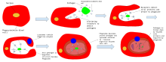Theengulfingofapathogenbyaphagocyte
Ina multicellularorganism's immunesystem,phagocytosisisamajormechanismusedtoremove pathogensprotozoa
Wherephagocytosisisusedasameansoffeedingandprovidestheorganismpartorallofitsnourishment,itiscalled phagotrophy andisdistinguishedfrom osmotrophy,whichisnutritiontakingplacebyabsorption.
VIRULENCEis apathogen'sormicroorganism'sabilitytocausedamagetoahost.Inmost,especiallyinanimalsystems,virulencereferstothedegreeofdamagecausedbyamicrobetoitshost.Thepathogenicityofanorganism—itsabilitytocausedisease—isdeterminedbyitsvirulencefactors.

BACTERIALVIRULENCEANDRESISTANCETOPHAGOCYTOSIS
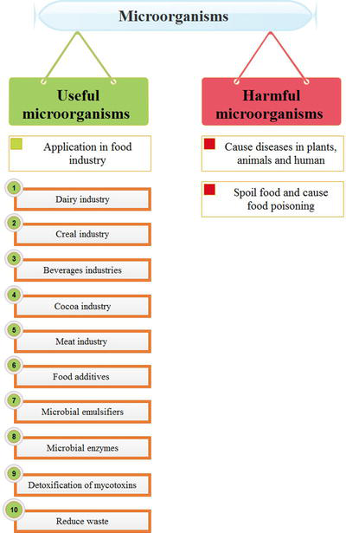

- Microorganismsarealsoinvolvedinthecommercialproductionofenzymes.Example:Productionoflipase.
- Ethanolisoneoftheimportantcommercialchemicalswhichisproducedby Saccharomycescerevisiae.
- ImmunosuppressiveagentslikeCyclosporinarepreparedfromthefungus, Trichoderma.
- Infoodprocessingtechnology,someofthemicroorganismsareusedforthepreservationofpackedfoodaswell.
Microbialpathogenesisis theabilityofmicrobes,ortheircomponents,tocauseinfectioninahostafterdevelopingacomplexmodeofinteractionsfrombothhostsandpathogens.

.Pathogenicinfectiousmicrobesarediverseinshape,surfacecomposition
Pathogenicmicrobes arespecializedtopropagateinanimmunocompetenthost,tospreadandtodisseminateintouniquehostcompartmentsandniches.The surface

Thesurfaceofpathogenicmicrobes
Pathogenicmicrobes arediverseinshape,surfacecomposition.ThecellmembranesofGram-negativeandGram-positivebacteriadiffer(Fig.2).The innermembrane isshieldedbyeitherasinglelayerof peptidoglycanspolysaccharidessurfacespeptidoglycanStreptococcuspyogenes isanexampleforapleiotropicandwellcharacterizedpathogenencodedcomplementandimmuneevasionprotein.TheMproteinhasahighlypolymorphicregionandindividualpathogenderivedproteinsbindmanyhumancomplementproteins,like FactorH,FactorHlike protein1 (FHL1),complementFactorHrelatedprotein1(CFHR1), C4bbindingprotein (C4BP),plasminogen,andalsocomponentsoftheextra-cellularmatrix(ECM)andbindstothesurfaceofhuman immunecells .Humanpathogenicyeastshaveacellenvelopeconsistingofaplasmamembrane, periplasmicspace andacellwallmadeofavarietyof glucans, chitinglycoproteins
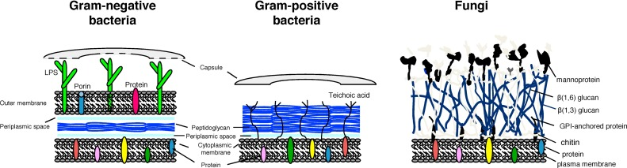
Signintodownloadfull-sizeimage
Fig.2. Pathogenicmicrobeshavedifferentsurfaces.Gram-negativeandGram-positivebacterialandfungalpathogenshaveadifferentsurfacecomposition.BacteriahaveaninnermembranewhichisshieldedbyeitherasinglelayerofpeptidoglycanincombinationwithasecondoutermembraneintowhichLPSisintegrated(Gram-negativebacteria)orthisinnermembraneisoverlaidbymultiplelayersofpeptidoglcycansintowhichteichoicacidsareintegrated(Gram-positivebacteria).Humanpathogenicyeastshaveacellenvelopeconsistingofaplasmamembrane,periplasmicspaceandacellwallmadeofavarietyofglucans,chitinandchitosan,mannansandglycoproteins.Manybacteriaandsomefungiareencasedbyanadditionalprotectiveshield,thecapsulewhichconsistsoflooselyattachedpolysaccharides.Inadditionmicrobeshaveuniqueproteinsintegratedintothemembranes,peptidoglycanlayersandcellwallmatrixesthatfaceoutwardandareexposedtotheenvironmentandthatcontacthostplasmaandcellcomponents.
Readmore

Infectiousorpathogenicmicrobes–whatisthedifference?
Infectiousmicrobesaregenerallyrecognizedandeliminatedbycomplementandthe immunesystem oftheirhumanhost.However, pathogenicmicrobes surviveinanimmunocompetenthumanorganism,astheyefficientlycontrolandblockcomplementandtheimmunereactions.Thus,‘immunologicallyvisible’microbesarerecognized,attackedandultimatelyeliminatedbytheefficientcomplementandimmunedefense.Incontrast‘immunologicallyinvisible’microbessurviveandpropagateaspathogens.Thus,pathogenicmicrobesusenumerousandhighlysophisticatedstrategiestocontrol,modulateandblockthecomplementresponseoftheirhost,andtheyalsocontrolinnateaswellasadaptiveimmunereactionsUponinfection,amicrobeaimstospreadandpropagatewithinavertebratehostandwithinthehumanorganism.Complement,asthefirstlineofhostimmunedefenseactsincombinationwiththeinnateimmuneresponseandformsaconstantandspecificattack.Thus,apathogenicinfectiousmicrobewhichsurvivesandpropagatesinavertebratehostinactivatesandcontrolseachofthespecificresponseofcomplement,andalsotheeffectorreactionsofinnateandof adaptiveimmunity.Overthelastyearsalargenumberofpathogenencodedimmuneevasionproteinshavebeenidentified,theircorrespondinghostligandshavebeendefinedandtheirprecisemodeofactionormechanismofimmuneinactivationhasbeendelineated.
Onecentralaspectofmoderninfectionbiologyistodefineinmolecularandmechanistictermsthedifferencebetweeninfectiousmicrobesthatarerecognized,attackedandeliminatedbytheactivatedcomplementsystemandby innateimmunity andpathogenicmicrobes,whichpersist,efficientlycontrolandinhibitthedamagingeffectoftheactivatedcomplementsystem.ThistopicisoffurtherrelevanceassuchmicrobialpathogensarediverseandasGram-negativeandGram-positivebacteria,fungi, protozoapathogenicity
Aftercrossingmechanicalbarriersliketheskinorenteringthevertebratehostviadamaged surfacessurfacefibrinogen

2.1 Pathogenicinfectiousmicrobesarediverseinshape,surfacecomposition
Pathogenicmicrobes arespecializedtopropagateinanimmunocompetenthost,tospreadandtodisseminateintouniquehostcompartmentsandniches.Thesurfaceofthesediversepathogensvariestoalargeextentbutalsoincludescommonstructuralcomponents,aswellasuniqueproteins.

2.1.1 Thesurfaceofpathogenicmicrobes
Pathogenicmicrobes arediverseinshape,surfacecomposition.ThecellmembranesofGram-negativeandGram-positivebacteriadiffer(Fig.2).The innermembrane isshieldedbyeitherasinglelayerof peptidoglycans.Manybacteriauseanadditionalprotectiveshield,andareencasedbyacapsulewhichconsistsoflooselyattached polysaccharidespeptidoglycanStreptococcuspyogenes isanexampleforapleiotropicandwellcharacterizedpathogenencodedcomplementandimmuneevasionproteinTheMproteinhasahighlypolymorphicregionandindividualpathogenderivedproteinsbindmanyhumancomplementproteins,like FactorH,FactorHlike protein1 (FHL1),complementFactorHrelatedprotein1(CFHR1), C4bbindingprotein (C4BP),plasminogen,andalsocomponentsoftheextra-cellularmatrix(ECM)andbindstothesurfaceofhuman immunecells .Humanpathogenicyeastshaveacellenvelopeconsistingofaplasmamembrane, periplasmicspace andacellwallmadeofavarietyof glucans, chitinglycoproteins
Signintodownloadfull-sizeimage
Fig.2. Pathogenicmicrobeshavedifferentsurfaces.Gram-negativeandGram-positivebacterialandfungalpathogenshaveadifferentsurfacecomposition.BacteriahaveaninnermembranewhichisshieldedbyeitherasinglelayerofpeptidoglycanincombinationwithasecondoutermembraneintowhichLPSisintegrated(Gram-negativebacteria)orthisinnermembraneisoverlaidbymultiplelayersofpeptidoglcycansintowhichteichoicacidsareintegrated(Gram-positivebacteria).Humanpathogenicyeastshaveacellenvelopeconsistingofaplasmamembrane,periplasmicspaceandacellwallmadeofavarietyofglucans,chitinandchitosan,mannansandglycoproteins.Manybacteriaandsomefungiareencasedbyanadditionalprotectiveshield,thecapsulewhichconsistsoflooselyattachedpolysaccharides.Inadditionmicrobeshaveuniqueproteinsintegratedintothemembranes,peptidoglycanlayersandcellwallmatrixesthatfaceoutwardandareexposedtotheenvironmentandthatcontacthostplasmaandcellcomponents.

2.2 Generalescapeprinciples
Pathogenicmicrobes controlandmodulatehostcomplementreactionsandevadehostimmunedefensesTothisendeachpathogenicmicrobeinterferesandinhibitsthedamagingcomplementandimmuneeffectorreactions.Pathogensbindmultipleanddistincthumanproteinsexpressnumerousescapeproteinsthatarediverseinsequence,havepleiotropicfunctionsandcontroldifferentimmunereactionsoftheirhosts.
Havingdescribedthefourcentralcircuitsofthehumancomplementsystem(seeSection 1.1),weheresummarieshowapathogenicmicroberespondsandcontrolsthecomplementattackoftheirhost.Torevealcommonstrategies,weprovidecentralexamplesofhowpathogenicmicrobestargetcomplementeffectorproteinsandhowtheymodulatethecomplementandimmunereactionsoftheirhumanhost.Thepathogenicmicrobetargetcomplementateachofthefourcomplementcircuitsandtherebyblocksandinfluenceshostresponse(Fig.3).
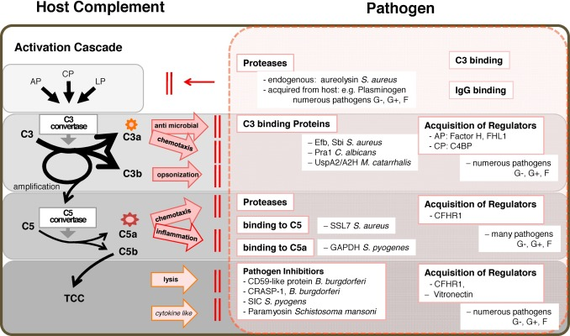
Signintodownloadfull-sizeimage
Fig.3. Pathogenicmicrobescontrolhumancomplementeffectorfunctions.ComplementEvasionproteinsofpathogenicmicrobescontrolinterferecascadeprogressionandamplificationandinterfereateachlevel.Complementactivationiscontrolledalreadyattheactivationlevel,e.g.,byproteases,C3acquiringproteins,aswellashostboundpre-proteaseslikeplasminogen.Attachedplasminogenisactivatedandconvertedtotheproteaseplasmineitherbypathogenencodedactivatorsandproteasesorbyhostacquiredactivators.ComplementevasionproteinsbindtoC3b,interferewithC3afunctionandblockC3bCR3,CR4interactionaswellasC3dCR2interactionandreceptorbinding.Inadditionmanypathogenicmicrobesbindhostplasmaproteinsandcomplementregulators.LikeFactorH,FHL1andC4BP,whichinfluenceC3convertaseactivityandfavordissociationoftheassembledcascade.MicrobialproteinsinterferewithC5circuitbuydegradingC5a,bindingandblockingC5b.SimilarlymicrobialpathogensacquireCFHR1ahumanC5convertaseinhibitor.MicrobialproteinsinterferewithterminalpathwaybybindingtocomponentslikeC7andbyacquiringthehumanTCCinhibitorsclusteringandCFHR1.G⁻,Gram-negativebacteria;G⁺,Gram-positivebacteria;F,fungi.

Interferenceatthecomplementactivationlevel
Pathogenicmicrobes influence complementactivation andalreadyinterfereattheactivationlevel.PathogenencodedproteinsbindtointactC3,andlikelyfreezeC3inthenativestateorconformation,andblockactivationandprocessing.
Inaddition,pathogenicmicrobesexpressandsecreteendogenousproteasesthatcleaveanddegradehumanC3andother complementcomponents. Aureolysinmetalloprotease of Staphylococcusaureus thatisanexampleofapathogenencodedproteasethatcleavesC3andinhibitscomplementactivation.Aureolysininhibits C3b deposition, opsonophagocytosis, bacterialkilling byhuman neutrophilsC5a.
Pathogenicmicrobesalsobindandacquireproteasesorproteaseprecursorsfromhumanplasma.Manypathogenicmicrobesbindthehumanpre-proteaseplasminogentotheirsurfaceandtheyuseeitherpathogenencodedorhostactivatorstogeneratetheproteolyticallyactive plasminstreptokinase from S.pyogenes ortheyutilizehostactivatorslikeuPAtogenerateactiveplasmin.PlasmincleavesanddegradesC3therebyblockingC3effectorfunctions.Manypathogenicmicrobesexpressseveralplasminogen bindingprotein.TheGram-negativebacterium Borreliaburgdorferi expressesatleastsevenplasminogenbindingproteins,theGram-positivebacterium S.pyogenes atleastfive)andforthehumanpathogenicyeast Candidaalbicans atotalofelevendifferentfungalplasminogenbindingproteinsareidentified.Thusinterferenceattheearlylevelofcomplementactivationisanefficientevasionstrategyleadingtoablockofdownstreameffects.Inaddition,pathogenicmicrobesusesurfaceproteinsthatbindIgGviatheconservedCterminaldomainandbindingproteins,immunoglobulins,liketheMproteinof S.pyogenes andProteinAof S.aureus,blockactivationoftheclassicalpathway.

2.2.2 InterferenceattheC3convertaselevel
Proteinsderivedfrom pathogenicmicrobes affecttheactionofthe C3convertase andinfluencetheC3convertasesinmultiplemanners.Theyeitherblockthe enzymeop.Thus,pathogensadjusttheactivity,aswellasthetypeandthenumberoftheeffectorcomponentsthataregenerated.Inaddition,microbialescapeproteinsinfluencetheactionoftheeffectormolecules.ThedensityandtypeofsurfaceattachedC3activationfragmentsdetermineshostresponseandeffectorfunctions.Thepathogenevasionproteinsinfluencetwomajoraspects;thenumberanddensityofsurfacedepositedC3boroftheotheractivationfragmentstherebyinfluencingopsonophagocytosisandmicrobialelimination.SimilarlyC3bprocessing,i.e.,thetypeofthesurfaceattachedC3activationfragmentmodulatesprocessingandhosteffectorfunction.TheimmuneevasionproteinSbiof S.aureus formsatripartitecomplexwithC3bandFactorH,andallowsfortripartitecomplexedC3bprocessingandinactivationbythecomplementprotease.
Acquisitionandbindingofsolublehumancomplementregulatorstothesurfaceofthemicrobialpathogenisacommoncomplementevasionstrategyandhasbeenshownformanymicrobialpathogens.ThemajorhumanproteinsthatareboundbyGram-negativeandGram-positivebacteriaaswellashuman pathogenicfungi and Plasmodiumfalciparum includeFactorHandFHL-1,humanregulatorsofthealternativepathway,aswellas C4BPation.
Severalpathogenicmicrobesexpress.Thesepathogenencodedproteins,whenboundtothehumaneffectorreceptorsmodulatecytoplasmicsignalingandinconsequencereceptormediatedeffectorfunctions.OneexampleisPra1from C.albicans,whichbindsCR3andtherebyinhibitsuptakeof Streptococcuspneumoniae bylungepithelialcells(Agarwaletal.,2010).AnotherexampleisandsecreteproteinsthattargetandbindtothecomplementeffectorreceptorsCR1,CR2,CR3,CR4or CRIgEfbof S.aureus whichisasapathogenencodedcomplementeffectorfunctioncontrollingprotein.Efbbindsto C3dteraction.

2.2.3 InterferenceattheC5convertaselevel
PathogensuseproteasesthatcleaveanddegradehostC5.SimilartothecontrolattheC3convertaselevel,suchproteasesareeitherencodedinthegenomeofthepathogenortheyrepresenthostregulatorsand plasmaproteins.ThestaphylococcalSSL7(staphylococcalsuperantigen-likeprotein7)bindsC5andtherebyblockscleavagebythe C5convertase (Langleyetal.,2005;Laursenetal.,2010).Glyceraldehyde-3-phosphatedehydrogenase(GAPDH)from S.pyogenes bindstoC5aandtheinhibitoryactionisassistedbyScpA,thestreptococcal C5apeptidase whichdegradesC5a.
Pathogenicmicrobes alsoacquireC5convertaseinhibitors,likehumanCFHR1,whichblocksC5convertaseactivitybutalsoTCCassemblyCFHR1bindinghasbeenreportedfor B.burgdorferi, Leptospira interogans, S.pyogenes, Pseudomonasaeruginosa, C.albicans and Aspergillusfumigatus.

InterferenceattheC5b-9level
Pathogensalsocontrolandinfluencetheactionoftheterminalpathway.ForalongtimeitwasconsideredthattheterminalpathwayofcomplementisrelevantforeliminationandkillingofGram-negativebacteria,andthatGram-positivebacteriaandfungiwiththeirthickcellwallsareprotectedfromthelyticactionoftheterminalpathway.Inthesedaysevidenceisincreasingthatmorepathogenscontrolandexploittheterminalpathwayofcomplement.TwoterminalpathwayinhibitorswereidentifiedfromtheGram-negative spirochete, B.burgdorferi,aCD59-likeprotein(Pausaetal.,2003)andCspA/CRASP-1,aC7bindingandTCCformationinhibiting/controllingprotein(Hallströmetal,submittedforpublication).TheGram-positivebacterium S.pyogenes expressesSIC(Streptococcalinhibitorofcomplement), Entamoebahistolytica expressesaGalactose-specificadhesinandthemulticellularparasites Schistosomamansoni and Trichinellaspiralis,useParamyosinforTCCcontrol(. S.mansoni usesSCIP-1(shistosomaCinhibitoryproteintype1)asasecondTCCinhibitingprotein.
Alargenumberof pathogenicmicrobes,againGram-negativeandGram-positivebacteria,aswellashumanpathogenicyeastbindvitronectin,thesolublehumanTCCinhibitor.Vitronectinisahuman plasmaprotein thatbindstoandblocksthemembrane bindingsite ofC5b-7andthepolymerizationofC9andtherebyblocksTCCaction.However,vitronectincontrolsadditional biologicalprocesses,includingadhesion,cellmigration, angiogenesis, Moraxellacatarrhalis and P.aeruginosa,theGram-positivebacteria S.aureus, S.pneumoniae and S.pyogenes andsimilarlythehumanpathogenicyeast C.albicans (Singhetal.,2010).Aspecificpathogengenerallyusesseveralvitronectin-bindingproteinsasexemplifiedbynon-typable H.influenzae thatattractsvitronectinwithbothproteinEandF,albeitatdifferentaffinities
Thisoverviewshowsthatmanypathogenicmicrobesinterferewithcomplementandapparentlytheyuseaseriesofcomplementescapeproteinstoinfluencecomplementaction.Apparentlytherepertoireofpathogeniccomplementevasionproteinsislargeandasinglepathogencaninfluencecomplementatmanylevelsandcontrolseveralstepsofcomplementactionandfunction,likelyalsoofeachindividualactivationfragment.

LABORATORYANIMALS“LaboratoryAnimals”aredefinedasanimalswhichareusedforexperimentalanddiagnosispurposewhichmayresembleinresultwithhumanbeings.TheycanbeverywellusedforcarryingoutvariousbiologicalexperimentsandresearchinbiomedicalaswellasveterinaryandanimalSCIENCES
Mice:areusedfortoxicologicalpurpose,microbiologicalandvaccineassay,insulintesting,ID,LD-50,studiesoncancertissuesvariousdrugstudies,especiallytoxicologyofvariousdrugs.80%ofexperimentsaredoneonrodents.About70%ofexperimentsaredoneonmice
Rat:areusedforpharmacologicalstudiesofvariousdrugs.InsulinresearchDiabetesandforvarioustoxicologicaltest.GuineaPigs:theselaboratoryanimalsareusedformicrobiologicalstudies,allergic,anaphylacticshockandpreparationofanti-sera.
Guineapigsareusedinlab.DiagnosisofT.B.BecauselesionsofT.B.areprominentinGuineapig
Hamster:theseanimalsareusedforcancertissuetestingparasitologicalandviriologicalresearch.
BACTERIALFORMS
Differentshapesofabacterialcellare:
- Spherical-Cocci.
- Rod-shaped-Bacilli.
- Spiralbacteria.
- Commashaped-Vibrio.
Bacteriaisaprokaryotic,unicellularorganism.Bacteriaarefoundeverywhere,theyarethemostabundantlivingorganisms.Theycanthriveinextremeconditionslikehotsprings,snow,deepocean,whereitisdifficultforotherorganismstolive.
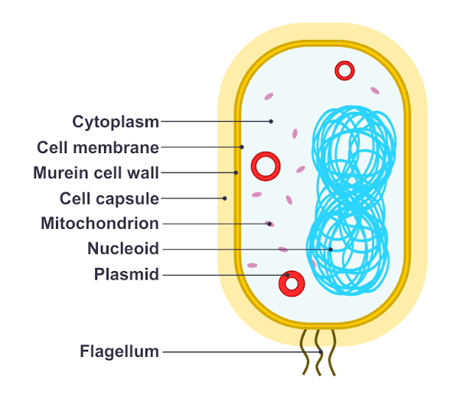

Salientfeaturesofbacteriaarethefollowing:
- Unicellularprokaryoticcell
- Presentindifferentshape,sizeandarrangement
- Thecelllacknucleusandmembrane-boundcellorganelles
- BacterialDNAisfoundinthecytoplasmandnotpackagedtoformchromatinasineukaryoticcell
- Bacteriacellis10timessmallerthanthehumancell
- Thediameterofabacteriacellis~1µm(10⁻⁶ m)
- Theoutercoveringofabacteriacellisthecellwall,whichisrigidandprovidesstructuralintegrity
- Thebacteriacellwallismadeupofpeptidoglycanormurein
- Differentshapesofbacteriacellarethecharacteristicfeatureofabacteriaspecies
- Bacteriacellsmaycontainexternalappendageslikecilia,flagella,etc.
- Bacteriacanbephotoautotrophs,chemoautotrophsorparasites
NutritionalTypesofBacteria

MorphologyofaBacteriaCell
Morphologyorshapeofabacteriacellisthemostdistinguishedpropertyofabacteria.Itisthecharacteristicpropertyofaparticularspecies.
Morphologyofbacteriacellnotonlytellstheshapebutalsodecidesitspathogenicity.Morphologicaltraitsofabacteriacellareanimportantfactorinitsadaptabilityandevolution.Therearemanyfeatureslikemotility,modeofnutrition,thatareaffectedbytheshapeofbacteria.
Thebacterialcellwallismadeupof peptidoglycan(murein),whichisapolymerofsugars,alternatingN-acetylglucosamine(NAG)linkedtoN-acetylmuramicacid(NAM)andaminoacidspeptidechain.Changeintheconfigurationofthepolymeranditsthicknessisresponsibleforthevariedmorphologyandshapeofabacteriacell.
MotileandNon-motileBacteriaExamples

SizeofBacteria
Thesizeofbacteriacanbeaveragedto2micrometreswithadiameterof0.5micrometres.Bacteriaareknowntodisplayawidevarietyofsizeandshapes.Theyareaboutone-tenththesizeofaeukaryoticcell.

Differentshapesofbacteria
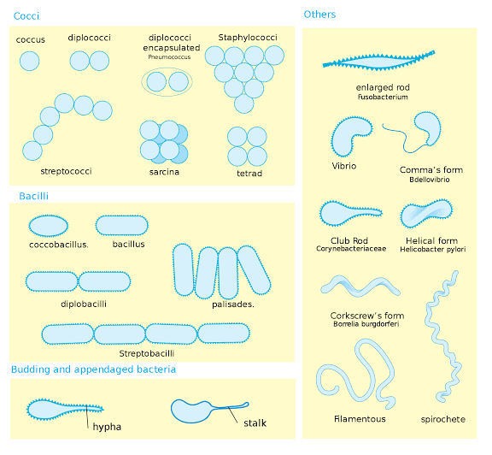
Differentshapesofbacteriaareusedtocategorisebacteria.Differentshapesofabacterialcellare:
- Spherical-Cocci
- Rod-shaped-Bacilli
- Spiralbacteria
- Commashaped-Vibrio
1.Spherical-Cocci:
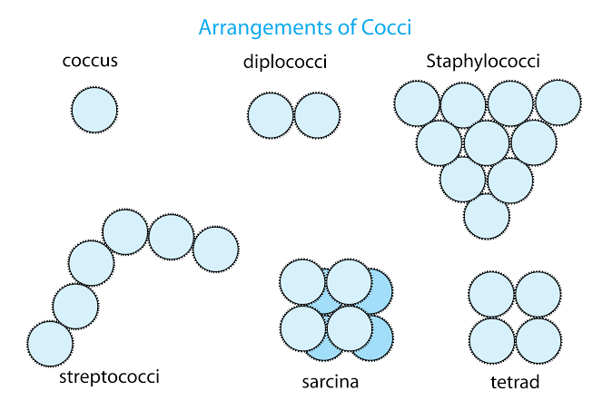
Coccicanbesingleormultipleinagroupof2,4,8,etc. Coccibacteria canberound,ovalorelongatedorbean-shaped.
- Thecellwallofcoccusshapedbacteriamaybegram-positivewiththickpeptidoglycanlayer,orgram-negativewiththethinpeptidoglycancellwall
- Thecellsdonotseparateaftercelldivision.Theplaneofcelldivisionchangestheshapeofthebacteria
Accordingtothearrangementofcells,coccibacteriaaresubdividedintovarioussubtypes:
- Monococcus: bacteriaexistasasinglesphericalcell
- Diplococcus: Cellsarearrangedinpairsaftercelldivision.Examplesofdiplococcusbacteriaare:Gram-negativebacteria- Neisseriaspp,MoraxellacatarrhalisGram-positivebacteria- Streptococcuspneumoniae,Enterococcusspp, etc.
- Streptococcus: thecocciarejoinedinaplaneandarrangedinachainpattern.Thesearenon-motile,aerobicandgram-positivebacteriathatcausemanydiseases.Examplesofstreptococciare Streptococcusmutans, Streptococcus pyogenes,Streptococcusbovis,Streptococcusagalactiae, etc.
- Tetrads: Tetradsarearrangedinagroupof4cells.Thecelldivisionoccursintwodifferentplanes.Examplesoftetradscoccibacteriaare Micrococcusspp,Pediococcus, etc.
- Staphylococcus: Cellsarearrangedinanirregularcluster,whichlookslikegrapes.Thisisduetothedivisioninthreeplanes.Examplesofstaphylococcusare staphylococcusaureus,Staphylococcushaemolyticus,etc.
- Sarcinae: Sarcinaebacteriaareanaerobicgram-positivebacteria.Theyoccurasagroupof8cells.ItisfoundinthefamilyClostridiaceae.Itisfoundinthelargeintestineandskin.Examplesofsarcinaeare: Clostridiummaximum,Sarcinaauranatica,Sarcinaventriculi,Clostridiummaximum,Microcioccusluteus,etc.
2.Rod-shaped-Bacilli:
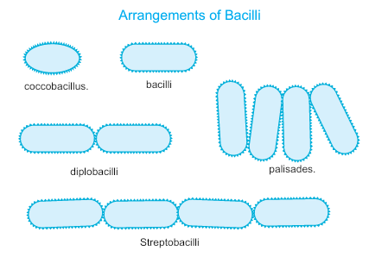
Thesearerodshapedbacteria.Theyalsooccursinglyorasmultiplecellsattachedafterthecelldivision.
- Bacilliformbacteriaarefoundinmanydifferenttaxonomicgroupsofbacteria
- Bacilliformbacteriacanbegram-positive,e.g. Actinomyces,Clostridium,Bacillus orgram-negativebacteria,e.g. Escherichia,Klebsiella,Salmonella,Streptobacillus, etc.
- Bacteriaofgenus Bacillus aregram-positive,rodshapedbacteria
  - Theyareobligateaerobeorfacultativeanaerobicbacteria
  - Theycanform endospores andliveforyearsasdormantandresistanttoheat,radiationanddisinfectants
  - Theycansurviveextremeheatandtempashighas420℃
  - Theyarethemostabundantbacteriaandfoundeverywhere
  - Mostlynon-parasitic,free-livingspecies
  - Twoparasiticandpathogenicbacillusspeciesare Bacillusanthracis causinganthraxand Bacilluscereus, whichcausesfoodpoisoning
Basedonthearrangementofrodshapedcells,bacilliareclassifiedintovarioustypes:
- Bacillus: Singleunattachedcell,thatlookslikearod.Examplesare Bacilluscereus,Salmonellaenterica, etc.
- Diplobacilli: Tworodsareattachedtoeachotherandfoundinpairsaftercelldivision.Examplesare Moraxellabovis,Klebsiellarhinoscleromatis, etc.
- Streptobacilli: Duetocelldivisioninoneplane,bacilliarearrangedinachain.GenusStreptobacilluscontainsgram-negative,aerobicorfacultativeanaerobicbacteria.Examplesare Streptobacillusmoniliformis,Streptobacillusfelis, etc.
- Coccobacilli: Theseareshortcomparedtootherbacilliandovalinshape,theyappearlikeacoccus.Examplesare Chlamydiatrachomatis,Haemophilusinfluenzae,Gardnerellavaginalis, etc.
- Palisades: Thebacilliaftercelldivisionbendandthereforearrangedinapalisade,fence-likestructure.Example: Corynebacteriumdiptheria
3.Spiralbacteria:
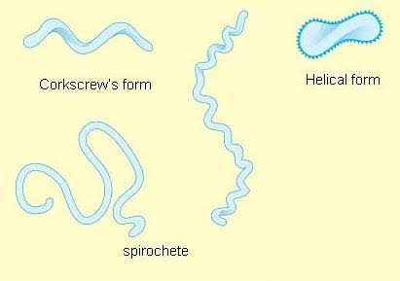
Thesebacteriaarespiralorhelicalinshape.
Basedonthethickness,flexibilityandmotilityofthecell,theyarefurtherdividedintotwotypes:
- Spirillum: Thesearegram-negative,rigidbacteriahavingexternalflagella.Examplesare Spirillum,Campylobacterjejuni,Helicobacterpylori,etc.
- Spirochete: Thesebacteriaarespiral,thinandflexible.Theyhaveinternalperiplasmicflagella.Thesearepathogenicspeciesthatcausevariousseriousdiseases.Examplesare Leptospira,Treponemapallidum,etc.
4.Commashaped-Vibrio:
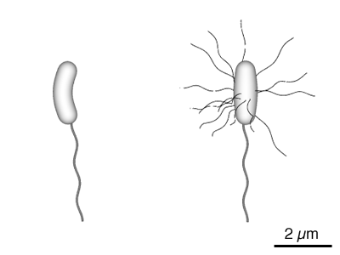
Thesearecurvedandappearlikeacomma.
- Thesearemostlygram-negativebacteria
- Theyareknowntocausevariousfoodbornediseases
- Vibriosp arefacultativeanaerobesandhave2chromosomeswhichreplicateindependently
Examplesare Vibriocholerae,Vibrioparahaemolyticus, etc.
Otherthanthemain4shapes,thebacterialcellpossessvariousdifferentmorphologynamely
- Filamentous: havealongfilamentousstructure.Example: Candidatussavagella
- Star-shaped: resembleastar.Example: Stellahumosa,Stellavacuolata
- Rectangular: theseareboxorrectangularshaped.Example:halophilicbacteriasuchas Haloarculavallismortis
- Pleomorphic: thesehaveabilitytochangetheirshapeandsizeduetovariousexternalfactorslikepressure,environmentalstress,etc.Example: Mycoplasmapneumonia,Mycoplasmagenitalium
- Appendaged: theyarealsoknownasbuddingbacteria.Theycanbenon-motileormotilewithflagella.Example: Hypomicrobium,Rhodomicrobium
- Trichome: trichomesareachainofvegetativecell.Thisisoftencoveredwithslimysheathasincyanobacteria.Example: Thiothrixnivea
- Lobed: thesehavealobedstructureandmostlyfoundinhotandvolcanicsprings.Theyareflagellatedandhaveanirregularshape.Theyareacidophilesandthermophiles.Example: Sulfolobusacidocaldarius,Sulfolobussolfataricus
- Fusiform: thesearespindle-shaped,bulgedinthemiddleandtheendistapered.Example: Fusobacteriumnecrophorum
- Stalked: astalkdevelopsatoneendofbacteriaduetoasymmetricalcelldivision.Example: Caulobactercrescentus
- Sheathed: bacteriacelliscoveredwithsheath.Theyarefoundinwater.Example: Leptothrix,Clonothrix

WhatisaProkaryoticCell?
Prokaryoticcellsaresingle-celledmicroorganismsknowntobetheearliestonearth.ProkaryotesincludeBacteriaandArchaea.Thephotosyntheticprokaryotesincludecyanobacteriathatperformphotosynthesis.
Aprokaryoticcellconsistsofasinglemembraneandtherefore,allthereactionsoccurwithinthecytoplasm.Theycanbefree-livingorparasites.

CharacteristicsofProkaryoticCell
Prokaryoticcellshavedifferentcharacteristicfeatures.Thecharacteristicsoftheprokaryoticcellsarementionedbelow.
- Theylackanuclearmembrane.
- Mitochondria,Golgibodies,chloroplast,andlysosomesareabsent.
- Thegeneticmaterialispresentonasinglechromosome.
- Thehistoneproteins,theimportantconstituentsofeukaryoticchromosomes,arelackinginthem.
- Thecellwallismadeupofcarbohydratesandaminoacids.
- Theplasmamembraneactsasthemitochondrialmembranecarryingrespiratoryenzymes.
- Theydivideasexuallybybinaryfission.Thesexualmodeofreproductioninvolvesconjugation.

ProkaryoticCell Structure
Aprokaryoticcelldoesnothaveanuclearmembrane.However,the geneticmaterial ispresentinaregioninthecytoplasmknownasthenucleoid.Theymaybespherical,rod-shaped,orspiral.Aprokaryoticcellstructureisasfollows:
- Capsule–Itisanouterprotectivecoveringfoundinthebacterialcells,inadditiontothecellwall.Ithelpsinmoistureretention,protectsthecellwhenengulfed,andhelpsintheattachmentofcellstonutrientsandsurfaces.
- CellWall–Itistheoutermostlayerofthecellwhichgivesshapetothecell.
- Cytoplasm–Thecytoplasmismainlycomposedofenzymes,salts,cellorganellesandisagel-likecomponent.
- CellMembrane–Thislayersurroundsthecytoplasmandregulatestheentryandexitofsubstancesinthecells.
- Pili–Thesearehair-likeoutgrowthsthatattachtothesurfaceofotherbacterialcells.
- Flagella–Thesearelongstructuresintheformofawhip,thathelpinthelocomotionofacell.
- Ribosomes–Theseareinvolvedinproteinsynthesis.
- Plasmids–Plasmidsarenon-chromosomalDNAstructures.Thesearenotinvolvedinreproduction.
- NucleoidRegion–Itistheregioninthecytoplasmwherethegeneticmaterialispresent.
Aprokaryoticcelllackscertainorganelleslikemitochondria,endoplasmicreticulum,andGolgibodies.

ProkaryoticCellDiagram
Theprokaryoticcelldiagramgivenbelowrepresentsabacterialcell.Itdepictstheabsenceofatruenucleusandthepresenceofaflagellumthatdifferentiatesitfromaeukaryoticcell.
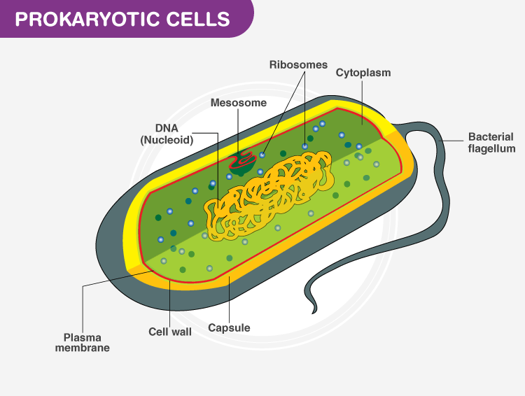
ProkaryoticCellDiagramillustratestheabsenceofatruenucleus

ComponentsofProkaryoticCells
Theprokaryoticcellshavefourmaincomponents:
PlasmaMembrane- Itisanouterprotectivecoveringofphospholipidmoleculeswhichseparatesthecellfromthesurroundingenvironment.
Cytoplasm- Itisajelly-likesubstancepresentinsidethecell.Allthecellorganellesaresuspendedinit.
DNA- Itisthegeneticmaterialofthecell.AlltheprokaryotespossessacircularDNA.Itdirectswhatproteinsthecellcreates.Italsoregulatestheactionsofthecell.
Ribosomes- Proteinsynthesisoccurshere.
Someprokaryoticcellspossessciliaandflagellawhichhelpsinlocomotion.

ReproductioninProkaryotes
Aprokaryotereproducesintwoways:
- Asexuallybybinaryfission
- Sexuallybyconjugation

BinaryFission
- TheDNAofanorganismreplicatesandthenewcopiesattachtothecellmembrane.
- Thecellwallstartsincreasinginsizeandstartsmovinginwards.
- AcellwallisthenformedbetweeneachDNA,dividingthecellintotwodaughtercells.

Recombination
Inthisprocess,genesfromonebacteriaaretransferredtothegenomeofotherbacteria.Ittakesplaceinthreeways-conjugation,transformation,andtransduction.
- Conjugation istheprocessinwhichgenesaretransferredbetweentwobacteriathroughaproteintubestructurecalledapilus.
- Transformation isthemodeofsexualreproductioninwhichtheDNAfromthesurroundingsistakenbythebacterialcellandincorporatedinitsDNA.
- Transduction istheprocessinwhichthegeneticmaterialistransferredintothebacterialcellwiththehelpofviruses.Bacteriophagesarethevirusthatinitiatestheprocess.
Eukaryoteorganisms haveoneormorecellswithanucleusandotherorganellesenclosedwithinmembranes.ProtozoaareunicellulareukaryoticmicroorganismslackingacellwallandbelongingtotheKingdomProtista.Thevegetative,reproducing,feedingformofaprotozoaniscalledatrophozoite

CharacteristicsofProtists
Theword protist isahistoricaltermthatisnowusedinformallytorefertoadiversegroupofmicroscopiceukaryoticorganisms.Itisnotconsideredaformaltaxonomictermbecausetheorganismsitdescribesdonothaveasharedevolutionaryorigin,termedpolyphyletic.Sincethecurrenttaxonomyisbasedonevolutionaryhistory(asdeterminedbybiochemistry,morphology,andgenetics),protistsarescatteredacrossmanydifferenttaxonomicgroupswithinthedomain.Historically,theprotistswereinformallygroupedintothe“animal-like”protozoans,the“plant-like”algae,andthe“fungus-like”protistssuchaswatermolds.Thesethreegroupsofprotistsdiffergreatlyintermsoftheirbasiccharacteristics.Forexample,algaearephotosyntheticorganismsthatcanbeunicellularormulticellular.Protozoa,ontheotherhand,arenonphotosynthetic,motileorganismsthatarealwaysunicellular.Otherinformaltermsmayalsobeusedtodescribevariousgroupsofprotists.Forexample,microorganismsthatdriftorfloatinwater,movedbycurrents,arereferredtoasplankton.Typesofplanktonincludezooplankton,whicharemotileandnonphotosynthetic,andphytoplankton,whicharephotosynthetic.

Protozoans
Protozoansinhabitawidevarietyofhabitats,bothaquaticandterrestrial.Protozoansareheterotrophic.Manyarefree-living,whileothersareparasitic,carryingoutalifecyclewithinahostorhostsandpotentiallycausingillness.Therearealsobeneficialsymbiontsthatprovidemetabolicservicestotheirhosts.Duringthefeedingandgrowthpartoftheirlifecycle,theyarecalledtrophozoites;thesefeedonsmallparticulatefoodsourcessuchasbacteria.Forexample,theprotozoaldiseasemalariawasresponsiblefor584,000deathsworldwide(primarilychildreninAfrica)in2013,accordingtotheWorldHealthOrganization(WHO).Theprotistparasite Giardia causesadiarrhealillness(giardiasis)thatiseasilytransmittedthroughcontaminatedwatersupplies.IntheUnitedStates, Giardia isthemostcommonhumanintestinalparasite
Thegenus Entamoeba includescommensalorparasiticspecies,includingthemedicallyimportant E.histolytica,whichistransmittedbycystsinfecesandistheprimarycauseofamoebicdysentery.Thenotorious“brain-eatingamoeba,” Naegleriafowleri,isadeadlyparasiteisfoundinwarm,freshwaterandcausesprimaryamoebicmeningoencephalitis(PAM).AnothermemberofthisgroupisAcanthamoeba,whichcancausekeratitis(cornealinflammation)andblindness.
Whilesometypesofprotozoaexistexclusivelyinthetrophozoiteform,otherscandevelopfromtrophozoitetoanencapsulatedcyststagewhenenvironmentalconditionsaretooharshforthetrophozoite.Acystisacellwithaprotectivewall,andtheprocessbywhichatrophozoitebecomesacystiscalledencystment.Whenconditionsbecomemorefavorable,thesecystsaretriggeredbyenvironmentalcuestobecomeactiveagainthroughexcystment.Oneprotozoangenuscapableofencystmentis Eimeria,whichincludessomehumanandanimalpathogens
Yeastsareeukaryoticmicroorganismsclassifiedasmembersofthefunguskingdomwith1,500speciescurrentlyidentifiedandareestimatedtoconstitute1%ofalldescribedfungalspecies.
ProtozoaareunicellulareukaryoticmicroorganismslackingacellwallandbelongingtotheKingdomProtista.Thevegetative,reproducing,feedingformofaprotozoaniscalledatrophozoite.Undercertainconditions,someprotozoaproduceaprotectiveformcalledacystthatenablesthemtosurviveharshenvironments.Cystsallowsomepathogenstosurviveoutsidetheirhost.
MUTATION,an alterationgenomecellvirusDNARNA (somaticmutation)maybetransmittedtodescendantcellsbyDNAreplicationandhenceresultinasectororpatchofcellshavingabnormalfunction,anexamplebeing cancerradiation (e.g., ultravioletlight orX-rays)orparticleradiationortohighlyreactivechemicalsinthe environmentdeleteriousbeneficialenvironmentsvariationevolution by naturalselection.
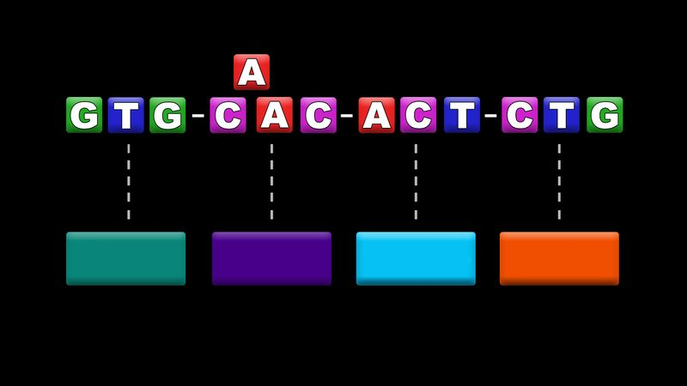

KnowhowasinglechangeintheDNAnucleotideresultsinmutationandwhysomemutationsareharmful.HowasinglechangeintheDNAnucleotidesequenceofagenecancausethewrongaminoacidtobeproduced.Thisdeceptivelysimplechangeinturncanaffectthestructureorfunctionofaprotein.Thoughsomemutationsareharmful,mostarenot.(more)
Seeallvideosforthisarticle
ThegenomeiscomposedofonetoseverallongmoleculesofDNA,andmutationcanoccurpotentiallyanywhereonthesemoleculesatanytime.ThemostseriouschangestakeplaceinthefunctionalunitsofDNA,the genesgenemutantallelegene’s transcriptionproteinuniquecodonadenine, thymine, guaninecytosine
Mutationsareofseveraltypes.Changeswithingenesarecalled pointmutations.Thesimplestkindsarechangestosinglebasepairs,called base-pairsubstitutions.Manyofthesesubstituteanincorrectaminoacidinthecorrespondingpositioninthe encodedsubstitutions
REPRODUCTION,processbywhichorganismsreplicatethemselves.Inageneralsensereproductionisoneofthemostimportant concepts in biologyspeciesof lifeevolution
Atitslowestlevel,therefore,reproductionischemicalreplication.Asevolutionprogressed,cellsofsuccessivelyhigherlevelsof complexityregeneration

